Task: Parker Square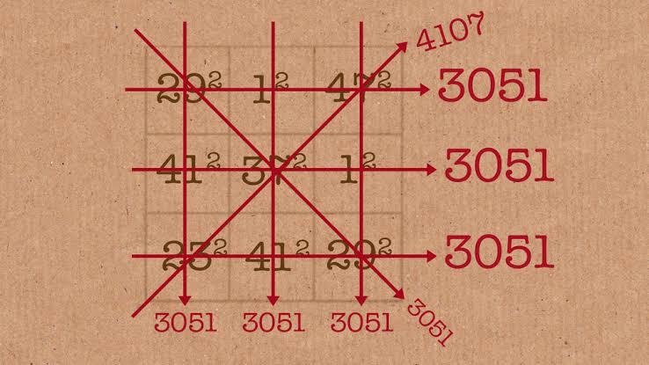

A parker square of order n is a square matrix which the sums of squares of all elements in each column, each row  ~~and diagonals~~ all are equal. You have to write a function that takes a square matrix as a parameter and return True iff it is a Parker Square.

Take a look at this Youtube Video [Parker Square](https://youtu.be/aOT_bG-vWyg) For the context of this task.

Your Task:

Let *arr* be a numpy array of shape n x n. You have to square each and every element of the array. Then you have to add the columns and rows and see if they come out to be equal.If they are equal then print Parker Square

Hint: use the axis parameter in the numpy.sum function

Solution:

We will consider the input as a valid n x n matrix. We prefer not to use loops in image processing

def is_parkersquare(matrix):

matrix_of_squares = matrix * matrix # element wise multiplication

sum_matrix_row =matrix_of_squares.sum(axis=1) #row wise sum

sum_matrix_column = matrix_of_squares.sum(axis=0) #column wise sum

element = sum_matrix_row[0] # Take any element from any of the sums

ans=(sum_matrix_row == element ).all() and (sum_matrix_column==element).all()

return ans

We will explain each line with example

a=np.array([[29, 1, 47],

[41, 37, 1],

[23, 41, 29]])

b= a*a

>>> array([[ 841, 1, 2209],

[1681, 1369, 1],

[ 529, 1681, 841]])

row=b.sum(axis=1)

>>> array([3051, 3051, 3051]) # sum of rows. similarly b.sum(axis=0) -> sum of columns

element = row[0] #take out one element

>>> 3051

element == row # compare each element of row with element

>>> array([ True, True, True])

(element == row).all() # Check if all are equal to single element

>>> True

(element==row).all() and (element==column).all() # Check if all columns and rows are equal to element

>>> True

Therefore this array is Parker Square

Now consider a False Case

a

>>> array([[1, 0],

[1, 3]])

b= a*a

>>> array([[1, 0],

[1, 9]])

row = b.sum(axis=1)

>>> array([ 1, 10])

element = row[0]

>>> 1

element == row

>>> array([ True, False])

(element == row).all()

>>> False

(element==row).all() and (element==column).all()

>>> False